Game Design Document

Fill up the Following document

1. Write the title of your project.

Shoot the Target

1. What is the goal of the game?

Shoot the center of any target within 5 bullets

1. Write a brief story of your game?

A Shooter wants to do his practice

1. Which are the playing characters of this game?

* Playing characters are the ones which respond to the user based on the input from the user
* Cars, monkeys, dinos, wizards etc, are the playing characters in the game.

|  |  |  |
| --- | --- | --- |
| Number | Character Name | What can this character do? |
| 1 | Gun scope | It can be Zoomed |
| 2 | Rifle | Shoots bullet |
| 3 | Shoot Button | Releases Bullet |
| 4 |  |  |
| 5 |  |  |
| 6 |  |  |
| 7 |  |  |
| 8 |  |  |

1. Which are the Non Playing Characters of this game?

* Non Playing characters are the ones which don't have an action or a behaviour when the user interacts with the game.
* Hurdles, stones, bananas, coins, etc are non playing characters in the game.

|  |  |  |
| --- | --- | --- |
| Number | Character Name | What can this character do? |
| 1 | Tree |  |
| 2 | Target | Have point where  Bullet should be  Shooted |
| 3 |  |  |
| 4 |  |  |
| 5 |  |  |
| 6 |  |  |
| 7 |  |  |
| 8 |  |  |

Draw your imagination of this game. What does this game look like?

* Draw the game either on your computer or on paper,
* Add images of scenes of the game to show each of the playing and non-playing characters at least once.

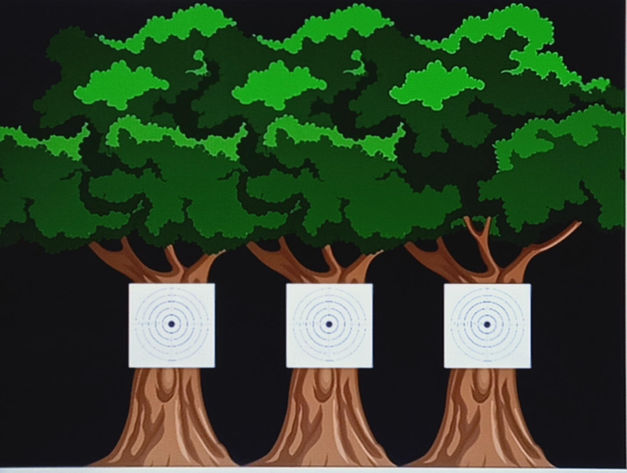

How do you plan to make your game engaging?

By adding more trees in Next Level